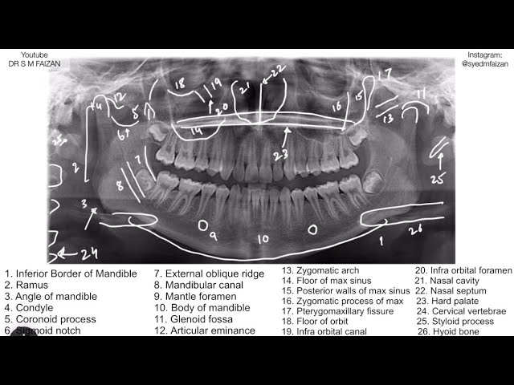
- For teaching purposes: AI to detect and highlight landmarks in dental radiographs (orthopantomograms)
- For educational use: students will select landmark, AI can say if it is correct or not
- For patient purposes: Identifying abnormalities, diseases, cavity, impacted teeth, etc
- Forensic Odontology: Estimating age using different parameters such as erupted teeth, teeth buds present, extent of root apex closure, cementum deposition, narrowing of pulp chambers.

NABH Training App for peons, clerks, doctors, in the form of games:
- Biomedical waste disposal
- Cleaning chemical spillage
- Blood spillages
- Sequence to follow in – Code Blue, Code Red, Code Pink, etc.
- One by one will work on the mini-games

